**aHTML** 🡺 hypertext markup language

      🡺 data presentation and UI designing  (sign up, login, registration, search form…)

        🡺We can design static web pages

**CSS** 🡺 Cascading Style Sheets

🡺 Used to change look & feel of webpage (html elements)

      🡺It helps to present data more effectively, attractively & animations

**JavaScript 🡺**it provides logical support to html pages

      🡺 its works like as back-end for html/css

      🡺used to develop interactive web pages

**BootStrap**  Bootstrap is a free and open-source CSS framework directed at responsive, mobile-first front-end web development.

Html, css, JavaScript & BootStrap are web technologies, these techs are used to develop **web applications**.

=> these tech are used to develop web applications

=> Web tech (html,css,js,bs)

     Types:

        1. Frontend tech (my course)

        2. Backend tech

=> Web app is collection of webpages

=> Web page is group of html elements

   Element means textbox, button, image, audio, video, para, heading, table, checkbox, radio....

=> using html tags we can create these elements

ADV:  data sharing/presentation, ui

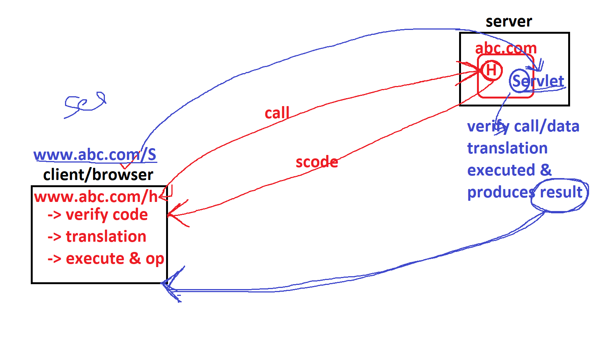

**Server**

A **server** is a computer or system that provides resources, data, services, or programs to other machines, known as clients, over a network/inet.

In theory, whenever computers share resources with client machines, they are considered **servers.**

a **server** stores all the data associated with the websites that are hosted by it and shares that info with all computers and mobile devices (like yours) that need to access them.

Server provides data services to clients

**Client**

A client is a device that connects to and uses the resources of a remote computer, or server.

Clients may use a desktop or a laptop or a tablet or a mobile phone or a TV or a car etc.

The device which is used by the user is called a “Client”.

Client is a media between server & end-user

**User**

The person who is working on/operating a client machine is known as User or end-user.

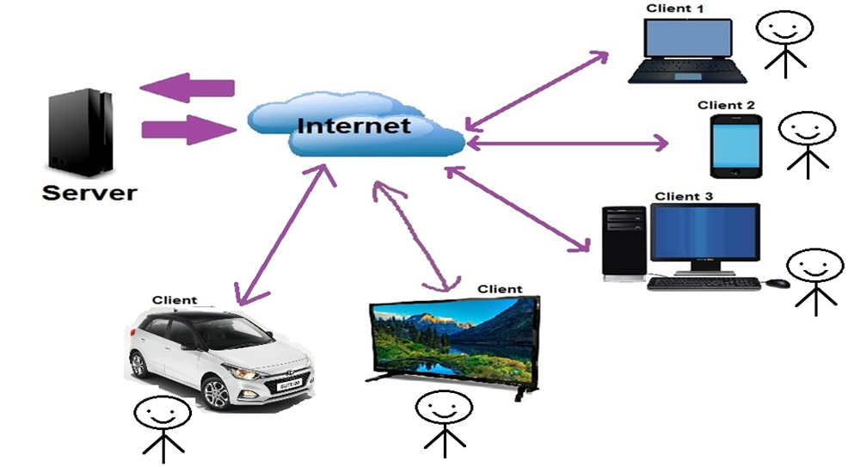

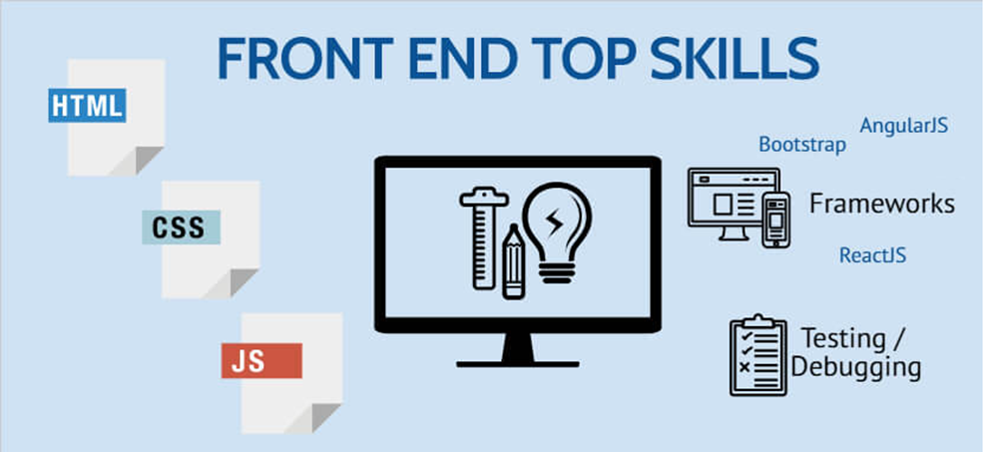

**WHAT IS APPLICATION OR SOFTWARE?**

Application is an Automation process of manual business operations (human being work) by using a programming language.

**WHAT IS WEB APPLICATION?**

Web applications are network enabled applications. We can deploy any web applications in servers and we can access them over the network using server ip address and application name.

In computing, a **web application** is a client–server software **application** which the client (or user interface) runs in a **web** **browser** and it contains web documents in the form of electronic pages (web pages).

**A web application typically contains following three layers:**

**Presentation layer** is a user interface (views) which are accessible from any web browser.

**Business layer** is a server-side program which is nothing but automation of business rules. Client layer will interact with the business layer to persist data.

**Data layer** is database software where we can store client related data. Business layer will interact with the data layer.

**HOW MANY TYPES OF WEB APPLICATIONS WE HAVE?**

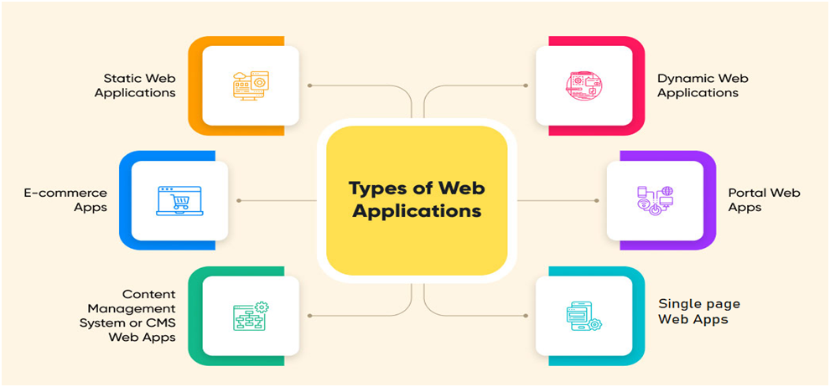

**Internet**

The Internet stands for international networking.

The Internet is a network of connected computers. No company owns the Internet; it is a cooperative effort governed by a system of standards and rules. The purpose of connecting computers together, of course, is to share information.

**A Brief History of the Web**

The Web was born in a particle physics laboratory (CERN) in Geneva, Switzerland in 1989. There a computer specialist named “**Tim Berners-Lee”** first proposed a system of information management that used a “hypertext” process to link related documents over a network. He and his partner, **Robert Cailliau**, created a prototype and released it for review. For the first several years, web pages were text-only.

**The World Wide Web Consortium (W3C)**

World Wide Web Consortium (called W3C) is the organization that oversees the development of web technologies. The group was founded in 1994 by Tim Berners Lee, the inventor of the Web, at the Massachusetts Institute of Technology (MIT).

**HTML**

It is specially designed hypertext for web browsers, with meaningful tags or elements in simple English language.

**HTML Versions**

From the W3C organization there are the following versions released.

**Version Specification              Release Date**

**1.0  N/A (HTML 1.0)             1993-dec/1994  bare bone**

**2.0  HTML 2.0                         24-Nov-1995**

**3.2  W3C: HTML 3.2              14-Jan-1997**

**4.0  W3C: HTML 4.0              24-Apr-1998**

**4.1  W3C: HTML 4.1              24-Dec-1999**

**5.0  WHATWG                        28-Oct-2014**

**5.1  W3C: HTML 5.1              Nov-2016**

**5.2  W3C: HTML 5.2              14-Dec-2017**

**HTML introduction**

1.    HTML was developed by **“Tim-Berners-Lee**”, released in 1993-dec/94 and maintained by W3C Org.

GML  ⇒   SGML  ⇒ HTML

                     90               91           94

  2.   HTML stands for “Hypertext Markup Language”.

“**Hypertext**” means the text that can be transferred from internet server to internet client.

**"Markup**" means which syntax will be in the form of tags or you simply "markup" a text document with tags that tell a Web browser how to structure it to display.

**“Language”** is an interface between web developer and web browser

3.    Technically, HTML is not a programming language, but rather a markup language.

 4.    HTML is used to design "static web pages", static web pages that always show the same information.

5.  HTML is very easy to understand (no prerequisites).

6.  HTML is “client side tech”. That means the html code executes on the client browser but not on the server.

7.  HTML is supported by all the browsers such as Google Chrome, Mozilla Firefox, Microsoft Internet Explorer, Safari, Opera and other browsers.

8.  HTML is used in all real time web sites today; html is the only language available in the world for designing Web pages.

9. For working html no need installs any software, and browser is responsible for executing & producing output of html programs.

                Typing & saving ⇒ notepad

                Execution & result ⇒ Browser

Notepad++, editplus

                VS Code, Sublime, Ec, netbeans

10. Html is error free programming.

       (while working with url/address only we will get errors)

11. HTML is not a case sensitive language that means you can write the html code in either uppercase or lower case.

14. HTML is an interpreter-based language. Browser interprets HTML code.

**Translators**: converting high level code (human) into machine level code (MP/OS) is called translation.

Who performs this operation are called translators.

**Types**:    compiler, interpreter, assembler

**interpreter**  it translates code line-by-line and executes line-by-line (interpretation)

                               interpreter

html code  ⇐=============⇒ machine code

(English)                                         (Binary code)

**Tag:**

·      A tag is a keyword, enclosed within "<" and ">" in HTML language.

·      It is a special kind of text placed between the left angular brace and right angular brace(<tag_name>).

·      Tag is a predefined program, program is instructions / command to the browser.

·      Tag is used to display some specific output in the web page.

·      Browser did not identify the tag; it shows a blank page or it prints as text.

·      tags also represented as elements.

**types of tags**

in html we have **two** types tags, those are:

1. **paired tags**

⇒ Contains open tag and closing tag.

⇒ Opening tag specifies starting point of operation/output, closing tag specifies ending point of operation/output.

Syn:   **<tagname>** text **</tagname>**

**ex:** <html>  ...  </html>

                 <head> ... </head>

                 <body> … </body>

                 <script> ...  </script>

<style> ... </style>

                <p> …  </p>

**note: paired tags also called as body-full tags**

**2. unpaired tags**

⇒ contains only open tag.

       Syn:   <tagname>     or  <tagname/>

**ex:** <br/>  <img/>   <input/> <hr> <link>    <meta>

**⇒** Unpaired tags also called as body-less tags

⇒self closed tags

**Structure of HTML**

As per **W3C** we have to follow the following structure to design web pages (but it’s not comp).

**<!DOCTYPE html>**

**<html lang=”en”>**

**<head>**

**</head>**

**<body>**

**</body>**

**</html>**

**Generally, html program contains three parts, those are:**

**> Versioning section**

**> Head section**

**> Body section**

**Versioning section**

This is providing information to the browser which version we are using in the web page/program. So, browser is interpreting code and producing output as per given specification.

Syn:      **<!DOCTYPE  html  version-url>**

HTML4.0:

**<!DOCTYPE html public "-//W3C//DTD HTML 3.0//EN" "http://www.w3c.org/TR/html3/strict.dtd">**

**<!DOCTYPE html>  ⇐ use’s new version of html**

strcit.dtd file (document type definition) contains definitions of tags and specifications.

**html tag**

The <html> tag represents the starting and ending of an html program. html tag contains two child/sub tags those are head tag and body tag.

**head tag**

head tag represents a non-content section (means not output) of the web page.

This information doesn't appear on the web page/in the browser (it's called as non-content), but it's used internally by the browser.

This tag is used to set icons, title, to provide some meta data (info about web app), css settings, java scripting etc...

head tag contains some child/sub tags, those are

**<link>,  <title>, <meta>,   <style>, <script> and <base> tags**

**body tag**

body tag represents content information (means output) of the web page.

this information appears on the web page/in the browser (it’s called content).

This tag is used to design UI or to display output.

body tag contains so many child/sub tags.

some of tags: **p**, **img, h1, table, div, a, table, audio, video, input, button, form, ol, ul, li, hr tags …**

**Comment lines**

⇒ Comment lines are to provide some description about our program.

⇒ Comments are not executed by browser.

**Syn:**

**<!-- text -->**

**html is a collection of tags(elements) and every tag has some attributes.**

**how design & execute html programs**

⇒ open any text editor (sw) and type program.

                notepad, editplus, notepad++, textpad, sublime, vs code, atom, coffee, ...

⇒ save that program with any name (.html or .htm) and anywhere in the system.

⇒ execution:

**1st Approach:** goto file location, then double click on file

**2nd Approach:** goto file location, then right click on file and click on open then select browser

**3rd Approach:** open any browser, then goto address bar and type filename with address.

for ex: d:/siva/test.html                         e:/test.html

**Heading tags**

These tags are used to print data/text in heading format.

Html provides 6 heading tags, those are h1, h2, h3, h4, h5 and h6.

These 6 tags are used to display headings in different sizes.

Six tags are paired tags and block level elements.

Syn:

          <h1> text </h1>

<h2> text </h2>

<h3> text </h3>

               …

**Note:** inside the body section we can repeat any tag and no of times.

**p tag**

> p stands for paragraph.

> this tag is used to display/print more lines of text (paragraph)

> its paired tag and block level.

Syn:

**<p> text or info </p>**

**Note:**

**>**browser/html doesn't accept more than one space (space bar & tab key), means while designing the program we are given more space but browser prints only one space.

**>**browser/html doesn't accept enter key (line breaking), means while designing a program we use enter key but browser prints data without breaking line.

**br tag**

èbr stands for break line (enter key)

èit moves the cursor to the beginning of the next line.

èits un-paired

**Syn:            <br>** or **<br/>**

**Html entities**

=> Entities nothing but Special characters or html operators

=> Special characters are used to perform some task or to print some Symbols.

=> Special characters is a English word

**Syn:**              **&**word**;                     
 ex:   &euro;  &copy;**

Html hexa-decimal codes, these codes are starts with #

Hexa-dec base 16 è 0,1,2,3,4,5,6,7,8,9,a,b,c,d,e,f

**Syn:     &#**hex-code**;**

**&#6digits;    &#4digits;**

**&#128525;   &#9876;**

**Formatting tags**

**b** tag or **strong**

> b stands for bold

> b & strong tags used to print text in bold format

> both are paired tags & inline tags

Syn:

<b> text </b>

<strong> text </strong>

**I** or **em** tag

>i stand for italic (inclined)

>i & em tags used to print text in italic format

>i is paired

Syn:

<i> text </i>

<em> text </em>

**u tag**

> u stands for underline

> u tag used to print text with underline (draws a line base of text)

> u is paired tag

Syn:

<u> text </u>

**strikeout tag**

> strikeout tag used to print text with line (draws a line middle of text)

>strikeout is paired tag

Syn:

<strike> text </strike>

**superscript tag**

>this tag used to display text top of upper line

> superscript is paired tag

Syn:

<sup> text </sup>

**subscript tag**

>this tag used to display text bottom of baseline

> subscript is paired tag

Syn:

<sub> text </sub>

All these tags are paired tags & inline tags

**Span tag**

>span tag used for small textual data, like as error message, mandatory specification.

> also in continuity of text, if we want to highlight couple of word or **letters** using css

>its paired tag, inline tag

Syn: **<span>** text **</span>**

**pre tag**

> pre stands for pre-formatting (alignment)

> pre tag is used to print data/text, how we typed in same format

> pre is paired tag, block level

Syn:

**<pre> text </pre>**

**Label tag**

> label tag used for displaying prompting text.

> its paired tag, inline tag

Syn: <label> text </label>

**title tag**

This tag is used to set the title for a webpage, meaning every webpage has an individual title.

Web site => 10 web pages => 10 titles (1page : 1title)

its paired tag.

<title> is the sub tag of <head> tag.

Syn:

<title> text </title>

**Link tag**

🡺 Link tag used to set the favicon/logo for a webpage.

🡺 Also used to link with external files (css file, bootstrap file)

🡺 Unpaired tag.

🡺 <link> is the sub tag of <head> tag.

**Syn: <link rel=”icon” href=”filename.ext”>**

**Relative =>** icon or stylesheet

**Hyper reference** => address of image/icon

.jpg .bmp **.png** .jfif.gif .tif **.ico .webp .svg**

**HTML Attributes**

⇒ Attribute is a special feature/setting of a tag.

⇒ every tag they have attributes 99%

⇒ An HTML attribute is a piece of markup language used to adjust the behavior or display of an HTML element. For example, attributes can be used to change the color, size, or functionality of HTML elements.

⇒ HTML Attribute is something that we use in the starting tag of HTML Elements or HTML Tags which provides extra information about those HTML Elements or HTML Tags.

Syn:

**<**tagname **attribute="value" attribute=’value’ ... >**

**Note:**

⇒ values should be enclosed within “ “ or ‘ ‘ or without quotes.

⇒ Every attribute must be separated by a space

* attributes right side of tag only

**Types of attributes**

**⇒ general attributes**

These attributes are common for most tags (99% of tags). These attributes are used to adjust the behavior or display of an HTML element, to provide extra information about those HTML Elements to the browser, to control size of element, to change alignment of element …

**those attributes are:**

**class, id, name, style, align**, **action, href, src, target, width, height, alt, title, min, max, step, maxlength, type, checked, selected, value, readonly, placeholder, rel etc…**

**⇒ event attributes**

An event is a notification that is triggered when something changes in the browser.

With event attributes these events are directed to JavaScript which then responds to the event.

These attributes are used to perform some logical operations.

logical operations we can perform by using JavaScript, these also called **dynamic attributes.**

By using event attributes From Html page we can trigger JavaScript code or we can call JavaScript functions

**attributes are:**

**on**click, **on**dblclick, **on**focus, **on**blur, **on**keypress, **on**keyup, **on**keydown, **on**submit, **on**change, **on**input, **on**reset, **on**select, **on**mousemove, **on**mouseout, **on**mouseover, **on**wheel, **on**load, **on**submit, **on**change etc…

**🡺Optional attributes**

Same as gen attribute, but there attributes are not comp to specify

**ex:** lang, method, type, …

**Images**

🡺 "img" tag is used to display images on webpage.

🡺 in one web pages we can display any no.of images and any type of images.

.jfif .svg .jpg .bmp .gif .tif .png .webp

🡺 its un-paired tag and its inline element

Syn:

**<img** attributes**/>**

**Note:**

It is strongly recommended to place all images in side root folder (or) create sub folder with name images in root folder

**attributes:**

**src** => to specify which img you want to display

**width** => width of image (pixel)

**height** => height of image (pixel)

**title** => it is used to specify tool tip. (whenever mouse pointer comes on top of image)

**alt** => alternative text, if image not loaded in webpage/not display, we want to display text message to user it called as alt

**hyper links**

> “a” tag stand for "anchor”

>"a" tag is used to create hyperlinks, hyperlinks are used to move from one webpage to another webpage.

>whenever the user clicks on the hyperlink, it moves to the specified page.

> source page and destination page sometime within the same application or other application.

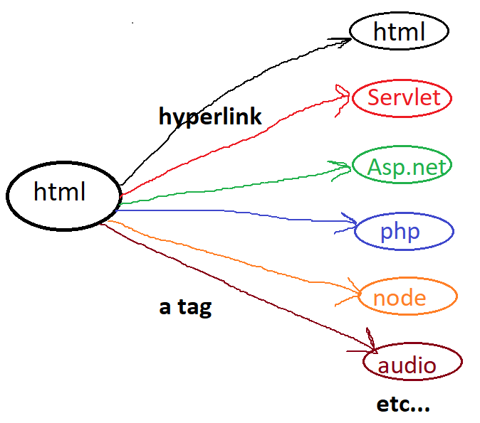



> by default, every browser provides built-in style for each hyperlink,

i.e blue color + hand symbol + under line.

We can customize these styles by using CSS.

> its paired tag, and inline element

**Syn:**

<a attributes> Display Text </a>

<a attributes> <img> </a>

**attributes:**

href : hyper reference, used to specify the address of webpage or web site,

i.e whenever user clicks on this link, which page you want to open

url may be html page, server-side file, image, audio file, video, pdf file, documents etc...

href=”url”

“<https://www.abc.com/login.aspx>”

“” self-calling

“.” 🡺 home page of web site/home dir of web application

“#id” 🡺for internal links

target : where you want open destination page

_blank ==> opens the link in a window/tab

_self ==> opens the link in current working tab/window (its default)

_top ==> opens the link in full body of window

framename ==> opens the link in specific frame

**working with list tags**

These tags are used to display data/info in points wise.

html supports three types of list, those are

Ordered list🡺 numbering

Unordered List 🡺 bullets

**ol tag**

>ol stands for "Ordered List".

>it is used to display the text(names, colors, team names, course name...) with numbering.

>it supports 5 types numbering, those are **1, A, a, i, I**. by default it displaying in number.

>by using "ol" tag we can create ordered list

>ol is paired tag & block level element

**li tag**

> li stands for "list item"

> li is sub tag of ol tag

> li tag is used to print text/data in points wise

> li is paired tag & block level element

Syn:

<ol attributes>

<li> text </li>

<li> text </li>

<li> text </li>

...

</ol>

**ol attributes:**

type : which type numbering to display (Default is 1)

start : from where u want to start numbering (default is 1)

reversed : to displaying numbers in desc order

**li attributes:**

value : used for restarting numbering with specified value

**ul tag**

>ul stands for "Unordered List".

>it is used to display the list of items(names, colors, team names, course name...) with bullets.

>It supports 3 types of bullets, those are **dot, circle, square**. by default, is dot.

>by using "ul" tag we can create unordered list items

> ul is paired tag

>"li" tag used for creating list items

**Syn:**

<ul type="dot/circle/square">

<li> text </li>

<li> text </li>

<li> text </li>

...

</ul>

**dl tag**

>dl stands for Definition list (since html5 description list)

>dl tag used for to display definitions/full forms (collection of definitions)

>its paired tag

> "dt" and "dd" are sub tags of "dl" tag

> "dt" stands for definition title, "dd" stands for definition data.

> dt & dd are paired

Syn:

<dl>

<dt>title/word</dt>

<dd>information</dd>

<dt>title/word</dt>

<dd>information</dd>

<dt>title/word</dt>

<dd>information</dd>

...

</dl>

**fieldset tag**

> this tag used for drawing a common border around elements/tags.

> its paired tag and block level

> we can draw any no of borders

**Syn:** <**fieldset** attributes>

<**legend**>text</**legend**>

Sub elements

</**fieldtset**>

**attributes:**

align : align of elements, it supports 3 alignments center, left, right

left is default align

border : style of line, thickness of line, color of line

width : width of box (size in % )

**legend tag**

>legend tag used for set title/heading for fieldset

>legend is sub tag of fieldset tag

>its paired tag

**Syn:**<legend attributes>Heading</legend>

**attributes:**

align :align of elements, it supports 3 alignments center, left, right

left is default align

color :

**Div tag**

> div is a **container**, means its grouping elements of html.

> inside the div tag we can place any content like normal text or images.

> div tag is used to divide web pages as no.of subpages/parts, each part is rep as div.

> for better maintained, effective design of web pages and simplifying css code.

>its paired tag, and block level element

Syn: <div attributes>

Contents (tags)

</div>

**table tag**

>table tag is used to display the data in form rows & cols in the web page.

> a table is a collection of rows, each row is a collection of cells/col/field.

> a table is represented as <table> tag, a row represented as <tr> tag, a colheading is represented as <th> tag, data rep as <td> tag.

> table heading is represented as <caption> tag.

><thead> tag is rep of table head part, <tbody> tag is rep of table body part and <tfoot> tag Is rep of table footer part.

**table**🡺 used to draw a table, means it grouping no.of rows

**caption**🡺 to set main heading of table

**tr** 🡺 table row, used to draw a row, means it grouping no.of columns

**th**🡺 table heading, used to set column headings

**td**🡺 table data, used to print the data in columns

**+**

**thead**🡺 table head section since html4

**tbody**🡺 table body section

**tfoot**🡺 table footer section

> all these 8 tags are paired tags

> table, tr, caption, thead, tbody & tfoot are **block level** tags

> th & td are **inline** tags

**Syn:**

<table>

<tr>

<th>heading</th> <th>heading</th>

</tr>

<tr>

<td>data</td> <td>data</td>

</tr>

...

</table>

**NOte:**

<th> and <td> are sub tags of <tr>

<tr> is sub tag of <table>

**table attributes:**

border : border of table (0 means no border, 1-n border req)

align : alignment of table

width : width of table (%)

...

**th& td attributes:**

colspan : specifies the no.of columns to merge/expend

rowspan : specifies the no.of rows to merge/expend

...